A Lawyer’s Guide for Buying a Laptop
If you've shopped for a laptop computer lately, you already know that it can be pretty confusing, particularly if you're looking for a Windows machine (where the options are nearly unlimited). The goal of this article is to explain what to look for, what to avoid and how to make an informed decision. I am specifically not taking sides on the Windows versus Mac PC debate and this article should be helpful regardless of which operating system you prefer. Further, the term "PC" as used herein refers to either a Windows or Mac computer. PC stands for personal computer which is defined as a computer designed for use by one person at a time. Although Apple's advertisements seem to declare that its computers are something other than PCs, they are not (all MacBooks and iMacs are PCs).
This article is not going to help you find the cheapest laptop possible. If your laptop is the primary tool you use to produce work product, then it's probably the last thing you should be cutting corners on. There are many compilations of the best "budget" laptops if that's what you're looking for. The following recommendations prioritize power, portability and reliability.
Laptop configurations and models change constantly so there's no point in identifying a particular model and configuration to buy. Instead, I'm going to describe what I would look for in a new laptop (component-by-component) and endeavor to explain each part of the PC so you'll understand what you're buying. Here we go!

Type of Laptop Computers Suitable for a Lawyer
I'm not going to explain every possible classification here because many of them are inappropriate for a law office (such as "gaming" laptops). You want a laptop designed for business use (rather than a home user/consumer PC). Business models tend to have longer product cycles and offer tried-and-true configurations that have been thoroughly tested. They typically offer better warranties (on-site service and accidental damage protection), physical durability, and built-in security.
You may also have heard of an "ultrabook" as a laptop category. Ultrabook is actually a specification for a laptop promulgated by Intel. Briefly, an ultrabook is a very thin, light and powerful laptop with great battery life, touchscreen capability and advanced security. Of course, many manufacturers offer business ultrabooks. An ultrabook may take the form of a traditional clamshell laptop, or a 2-in-1 hybrid or a 2-in-1 convertible. Good examples of traditional ultrabooks include the Dell XPS 13 and the Lenovo ThinkPad X1 Carbon. A hybrid 2-in-1 is a laptop where the screen can be detached from the keyboard base and used as a touchscreen tablet (see a Microsoft Surface Pro 7 for example). The screen on a convertible 2-in-1 doesn't detach but can be flipped back, swiveled or slid into a position so that it can also be used like a touchscreen tablet (see an HP Spectre x360 for example).
More recently, Intel introduced a successor to the Ultrabook classification called Evo. Intel says that Evo is for those who “[w]ant a laptop that has it all.” And who doesn’t want that? Briefly, in order for a manufacturer’s laptop to qualify for the Evo designation, it should possess: 1) an 11th generation (or later) Intel Core processor with Intel Iris X graphics; 2) support for Wi-Fi 6 technology; 3) the ability to run for at least nine hours on battery power; 4) fast “wake from sleep” technology; and 5) Thunderbolt 4 connections for external docks, high-resolution screens, and other peripherals.

What To Know About Processors
3/5/7/9 DESIGNATION
In a nutshell, an Intel i9 processor is more powerful than an i7; an i7 is more powerful than an i5; and an i5 is more powerful than an i3. There are also m3, m5 and m7 processors in addition to the "i" series. The "m" processors allow manufacturers to create notebook PCs that have no cooling fans (which allows them to make thinner devices that make less noise); and the "m" processors provide longer battery life than the "i" processors. However, the "i" processors are faster and nearly all of the “m” processors are discontinued or being phased out. The only “m” still in production is the lowest-end m3 series. It is best to avoid them for professional work.

Generations
Intel has released 12 "generations" of the 3/5/7/9 processors so the current release is creatively called "12th gen." If you're buying something new and it doesn't indicate that the processor is 12th generation, make sure you ask. You can also tell what generation a processor is by looking at the first number following the 3/5/7/9 designation. For example, a configuration that includes an i7-12700 processor is 12th generation. The number 12 that begins the five-digit number following the i7 is the indicator that it's a 12th-generation processor. If that number was a 11, it would be 11th generation. Every generation of processors gets a little faster and adds various other benefits. Laptop and desktop processors are developed and released on different schedules. While Intel has release a 12th generation of processors for desktops, on the laptop side, the 11th generation is top of the line. For the full rundown on what the 11th generation processors provide, see the Intel press site at https://www.intel.com/content/www/us/en/products/docs/processors/core/11th-gen-core-mobile-processors-brief.html.

Processor Recommendation
If you only use your PC for e-mail, Internet browsing, and light applications like word processing, an i3 would probably be fine. If you're using more taxing applications (such as case management systems, document management systems, or legal accounting programs), consider a 11th-generation i5 or i7. All major manufacturers have 11th-generation offerings out at this point, but there are a lot of new computers out there with 10th generation processors. It makes sense to look for the latest generation processor unless you really want to save money by buying an older one. Between the 5, 7 and 9, an i5 or i7 is suitable for almost all lawyers. If you have more demanding applications like photo/video editing or speech recognition, you may want to consider moving up to an i9, although the size, heat, and power requirements will increase quite a bit. While it may be true that "[f]or most users, the extra features and processing power of the Core i7 [over an i5] won’t be worth the cost difference between the two tiers," I've never met anyone who regretted choosing more power.

Graphics or Display Adapter
The graphics adapter is the part of a computer which processes the images so they can be displayed on the screen or monitor. There are two basic architectural approaches for a graphics adapter: integrated and discrete. Integrated means "locating a computer's display circuitry in the chipset on the motherboard rather than on a separate plug-in card." Discrete graphics adapters are typically a separate circuit board inside the computer and are more powerful than integrated adapters. Integrated graphics adapters are typically sufficient for legal users since the applications used are not demanding from a graphics/video perspective. However, you may want to consider a discrete graphics adapter if any of the following apply to you:
• You want to connect a large external monitor (greater than 27");
• You want to connect to a high resolution monitor (4K or 3840 x 2160);
• You want to connect to 2 or 3 monitors simultaneously;
• You need to engage in video editing; and/or
• You run graphics-intensive applications on your computer like computer-aided-design ("CAD") programs or games.
You can do all of the foregoing with integrated video, but the performance of the computer may suffer.
Having said all of that, the model of computer you choose may offer you no choice in display adapter. If it's a business computer, it may only offer integrated video. I have two 24" monitors connected to a laptop with integrated video and it's fine. However, if I had a choice between integrated and discrete, I'd go with discrete because of external monitors I connect to my laptop. Again, no one ever regrets better performance. Below is a screenshot of a configuration from a Lenovo ThinkPad T15. The Nvidia GeForce MX450 is a discrete video option. Intel UHD (in the first option) means integrated video. As you can see, there's not a huge price jump to get a much more powerful display adapter.
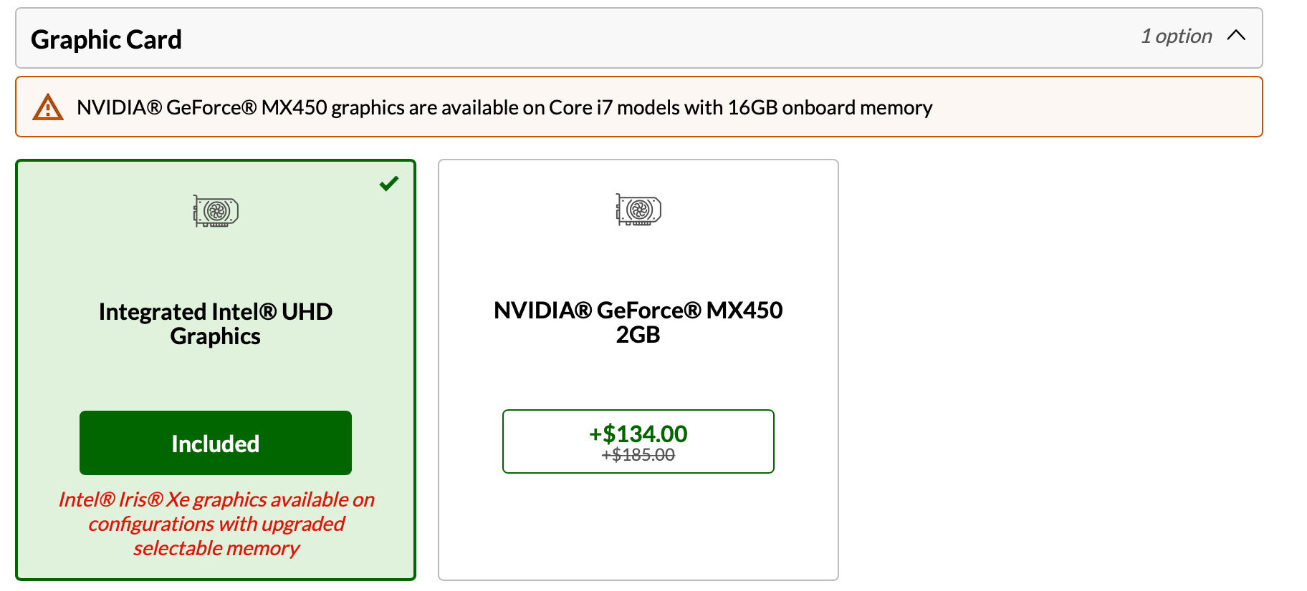
In addition to the price increase for discrete graphics – $134 in the ThinkPad example – both the laptop has a higher starting price – $1,500 for the ThinkPad – than similarly-capable machines without extra graphics power. They also weigh more. There are few to no thin & light options with integrated graphics.

Memory or RAM
For normal business usage, I would recommend 16 GB of RAM. If possible, get the memory on one memory chip. Most laptops have two memory sockets on board so if you get all of your memory on one chip, then you can easily add another one later as a an upgrade. If you get 16 GB comprised of two 8 GB chips, then to upgrade your memory, you'll have to discard half of what you already have. If you're wavering on the amount of RAM to buy now, remember that, for many Windows laptops but not for Mac laptops, it's usually an easy DIY project to upgrade your RAM later. Companies like http://www.crucial.com/ make it exceedingly easy to upgrade RAM because their website allows you to determine exactly what type of memory your computer requires and their prices are very competitive.
Additionally, some manufacturers, particularly for their “desktop replacement” style laptops with i7 or i9 processors, like the ThinkPad T15, may have two distinct memory options – one that is built-in to the motherboard and must be chosen at purchase time and a second bank of memory that can be upgraded at a later date.
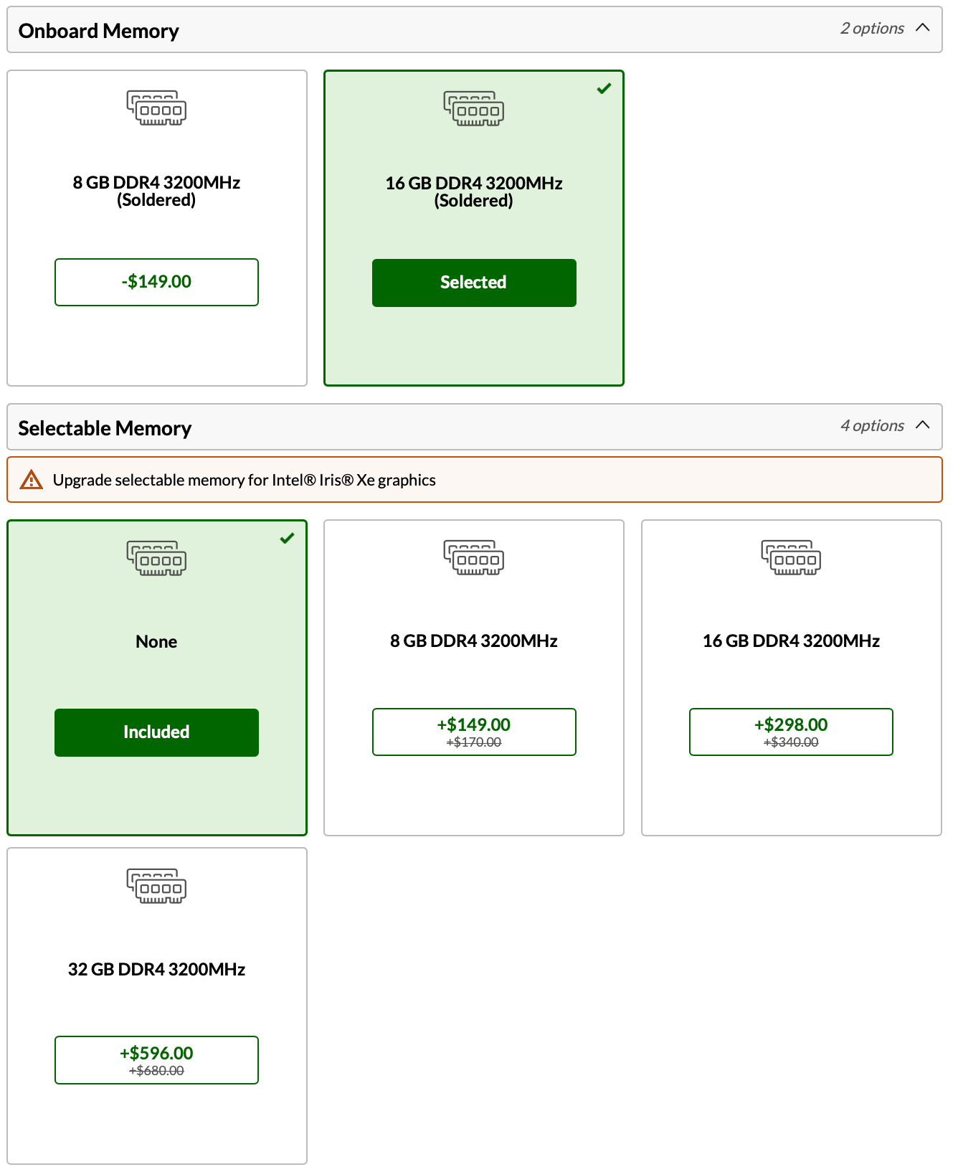

Hard Drive Options

Types of Drives
There are 3 kinds of hard drives, mechanical (HDD - Hard Disk Drive), solid state (SSD - Solid State Drive) and hybrid (SSHD). In laptops, we strongly recommend SSDs but they're not completely necessary in desktops. Go with an SSD if you can afford it. Here's a good explanation of the differences between HDD and SSD:
"The traditional spinning hard drive (HDD) is the basic nonvolatile storage on a computer. That is, it doesn't 'go away' like the data on the system memory (RAM) when you turn the system off. Hard drives are essentially metal platters with a magnetic coating. That coating stores your data, whether that data consists of weather reports, a high-definition copy of the Star Wars trilogy, or your digital music collection. A read/write head on an arm accesses the data while the platters are spinning in a hard drive enclosure.
An SSD does much the same job functionally as an HDD, but instead of a magnetic coating on top of platters, the data is stored on interconnected flash memory chips that retain the data even when there's no power present. These flash memory chips differ from the flash memory in USB thumb drives in the type and speed of the memory. That's the subject of a totally separate technical treatise, but suffice it to say that the flash memory in SSDs is faster and more reliable than the flash memory in USB thumb drives. SSDs are consequently more expensive than USB thumb drives for the same capacities."
It should also be noted that HDDs have a speed rating in terms of RPM. This refers to the speed with which the magnetic platters inside the drive rotate. The faster they rotate, the faster your computer can access information. You should avoid 5,400 rpm drives because they're too slow. Instead, look for a 7,200 rpm drive or faster.
A hybrid drive combines a very small SSD with an HDD in the same device. They're far less expensive than SSDs, and offer modest performance improvements. Having said all of that, you definitely want maximum performance, an SSD if it's available (as mentioned above). They cost more but they're worth it. SSDs are much faster than mechanical or hybrid drives, they use less electricity, generate less heat, and have no moving parts so they are less likely to "crash."

Size
For most legal users, we recommend a 256 GB or 512 GB SSD. If you store almost everything on a server or the cloud, then the smaller size should be fine. If you have larger storage needs, you might be forced to go with an HDD rather than a SSD. It's easy to find 1 TB (1,000 GB) or larger HDD options in a laptop. It used to be more difficult to find them with an SSD, but higher end manufacturers, like Lenovo and Apple, offer 1TD or more. Indeed, Apple’s pro machines can be equipped with an SSD up to 8TB, at a considerable price premium.

Screen Options

Screen Size
What size screen you choose is really a matter of personal preference. My current laptop has a 13.3" screen which is extremely popular among laptop manufacturers and I like it. I have migrated over the years from a 15.6" screen to a 14" and now a 13.3". I have no problem seeing things on my 13.3" screen. Many models offer a 15.6-inch screen but I wouldn't recommend going larger than that. Remember that a bigger screen generally means a heavier laptop and less battery life, but that may be worth the trade-off depending on your usage.

Resolution
If you have a choice of resolutions on the screen, choose a higher resolution option if you intend to plug external monitors into your laptop and use it primarily in that arrangement. Higher resolution screens mean that everything will be sharper, but also smaller. As such, it does little good to get a high-resolution screen that renders everything so small that you can barely see it. If you are connecting to an external monitor, this typically is not an issue because the external monitors are so much larger. The native resolution on my MacBook Pro is an amazing 2560 x 1600. However, it made some things so small that I could barely see them. I reduced the resolution to 1440 x 900 and I could see things much better.

Touch
Many laptops now offer a touch screen. Even if you don't think you'll use it, there's no reason to avoid one of these. It's actually pretty handy when you're reading a document or scrolling down a web page. Currently, no Apple laptops offer a touch screen but all of its competitors in the Windows world do.

Recommendation
I recommend a 13.3" or 14" touch screen if your eyesight is good enough to see things easily on a smaller screen.

Operating System Considerations

Windows PC
If all of your software is certified to work with Windows 10, then you should definitely go with Windows 11 Pro (not Home), 64 bit.

Mac
There are no operating system choices to make.

Warranty Options

Recommended System Warranty
Ideally, you want at least a 3 year, next-business day, on-site warranty with 24x7 technical support. If you think you'll be using your computer for longer, then most manufacturers will give you the option to extend your warranty to 4 or 5 years. I generally prefer to cycle out computers every 3 years so I never get a warranty beyond that. Mail-in or carry-in warranties are going to extend your downtime and likely cause you a lot of waiting and frustration. In my opinion, warranties that require me to ship my computer somewhere or take it to a store are unacceptable.

Warranties from the Manufacturer Are Better
For example, if I buy a Dell laptop from Amazon.com, they don't offer Dell factory warranties for the computer. Instead, they offer third party warranties and those warranties are, in my personal experience, vastly inferior to the warranties purchased directly from Dell (like Dell's ProSupport warranties).

Technical Support
I look for North American-based support from representatives for whom English is their first language. Nothing is more frustrating than trying to explain a problem to someone you can't understand. It's worth asking the question before you buy the computer - where is the support based? If technical support is off-shore and you can't upgrade to something better, then you might want to keep looking.

Accidental Damage Protection
If you are worried that you might accidentally break your laptop, this is an excellent added measure of protection. This protection is normally recommended for laptop computers, but it's probably not worth it for a desktop. It protects you against liquid spills, drops, falls, and surges (electrical). Manufacturers like Apple, Lenovo, and Dell offer this kind of coverage and it's surprisingly inexpensive for 3 years.

Security Issues

Antimalware and Firewall Software
At a minimum, you need antivirus software and a firewall. Broadly, antivirus software keeps malware off your computer and a firewall keeps hackers out. Windows 11 computers have both of these things built in, but the built-in options (like Windows Defender) typically rank at the bottom of antivirus reviews. Macs do include a firewall but not an antivirus program so you definitely need to buy one. Some of the big players for Windows or Mac include Bitdefender (my favorite), McAfee, Kaspersky, Webroot and Symantec.

Fingerprint Reader
Fingerprint (biometric) readers allow you to block unauthorized users of your computer and login quickly without entering a password. Many manufacturers include free encryption software with your system when this option is selected. This allows you to encrypt your computer so it is unusable without a valid fingerprint swipe. This added level of security is well worth the added cost.

Hard Drive Encryption
If you're going to have confidential client information on your desktop PC, then in my professional opinion, you need to encrypt the hard drive. This can be accomplished several ways. If you have a MacBook, it comes with an encryption program called FileVault. If you have Windows 11 Pro, then you have an included encryption program called BitLocker. You can also buy encryption programs for your PC like SecuriKey Pro for Windows or Mac. Finally, you may have an option when configuring a new desktop to choose a self-encrypting hard drive.

Bundled Office Suite
If you get Microsoft Office preinstalled on your new computer, then the software license typically restricts it to being installed only once and only on the computer it came with. For that reason, more lawyers are choosing to get Microsoft Office as part of a Microsoft 365 bundle. You can transfer those installations of Office from one computer to another, you get both the Windows and Mac versions, and you can install it on up to 5 PCs that you use. For more information on this, see http://tinyurl.com/hqvke9z.

Keyboards
I prefer a backlit keyboard if it's available. I am often using my laptop in low-light situation and although I've been typing for a lot of years, I still want to see the keyboard, particularly when I need to hit an F key. If you're a touch typist, it's also worth test driving the keyboard before you buy. Keyboards are definitely not all created equal, even within the same brand.

Battery
Laptop batteries are measured in terms of "cells." The more cells in your battery (3, 4, 6 & 9 are typical), the longer you'll be able to operate unplugged. You should also know that the bigger the battery, the heavier your laptop will be. If the laptop you choose has user-swappable batteries, I recommend getting an extra one as a backup. Otherwise, you can buy external laptop battery chargers for emergency situations. These external batteries charge via USB or USB-C and can “top off” USB-C-powered computers, as well as smartphones and tablets.

Webcam and Mic
Any business laptop should have a built-in webcam and integrated mic so you can participate in Web meetings, Skype, and use other similar services without buying any additional accessories.

Optical Drive/DVD
Today, the vast majority of laptops do not include an optical drive of any type. While most software used to come on DVD, today it's most often downloaded. If you need an optical drive, you're better off getting an external drive which connects via USB and you can use it when you need it. You can buy a nice USB 3.0 external DVD drive for about $35 online.

Ports
A port is a connection point for attaching peripherals or other external devices to your computer. When buying a laptop today, I would want multiple Thunderbolt 3 and/or USB-C ports. These ports use the same types of cables and devices are interchangeable between them. These are new, extremely high-speed ports that can transfer data while also supplying power. In terms of data transfer, Thunderbolt is faster than USB-C, but devices that work with one will work with the other.

Docking Stations or Port Replicators
A docking station or port replicator (a "dock") is a peripheral that connects to your laptop and allows you to connect many other devices to your laptop simultaneously. In many cases, a dock can also provide power to your laptop. For example, I have a CalDigit T3 Plus Thunderbolt dock (https://www.caldigit.com/ts3-plus/). One Thunderbolt cable connects to my laptop and provides charging power and access to 15 ports on the dock, including five traditional USB ports, gigabit ethernet, optical audio, two USB-C ports, a second Thunderbolt port, a DisplayPort connection, and an SD card slot. All through one cable to my MacBook.
Connected to the dock, I have two 24" monitors, an external keyboard, mouse, a Fujitsu ScanSnap iX1600 scanner, a network cable (providing Internet and connectivity), and a Logitech webcam. As a result, connecting the one little Thunderbolt cable to my laptop automatically connects me to all of those peripherals. When I'm ready to go home at the end of the day, I simply unplug the dock and leave with my laptop. At home, I have another dock with all of the same peripherals connected so I can work from either location in the same manner. All of this may not sound like a big deal, but having a dock is a huge convenience. Further, my laptop doesn't have enough built-in ports for me to connect to all of those things simultaneously so a dock is really the only way I can do it. The CalDigit T3 Plus (MSRP $250) is one of many Thunderbolt docks on the market.

See Computer & Laptop Reviews & Top Picks, Lifewire, at https://www.lifewire.com/computer-and-laptop-reviews-4102643, and The Best Laptop Under $500, by Thorin Klosowski and Kimber Streams, at https://www.nytimes.com/wirecutter/reviews/best-laptop-under-500/.
See http://www.intel.com/content/www/us/en/2-in-1/laptop-tablet.html.
See https://www.intel.com/content/www/us/en/products/systems-devices/laptops/evo.html.
Intel Core i5 vs. i7 processors, by John Martindale and Jacob Roach, April 21, 2021, Digital Trends, see http://www.digitaltrends.com/computing/intel-core-i5-vs-i7/.
See https://en.wikipedia.org/wiki/Intel_Graphics_Technology.
See https://support.apple.com/en-us/HT204837 for more information.
See A Beginner's Guide To Bitlocker, Windows' Built-In Encryption Tool by Ian Paul, August 1, 2016, PCWorld, see http://tinyurl.com/jdc6xkd.
See https://shop.securikey.com/Default.asp.

